1. [5 marks: 2, 3]  
  
 A complex number,  *z* = *a* – *i* , where *a* is a real number.  
  
(a) Give  in rectangular form.

(b) Evaluate *a* if *z*2 = 8 + 6 *i*

2. [4 marks]  
  
 Sketch, on the complex plane provided below, the region defined by  
 ⏐*z* − 3⏐ < 3 ∩  ≤ arg *z*  ≤ 

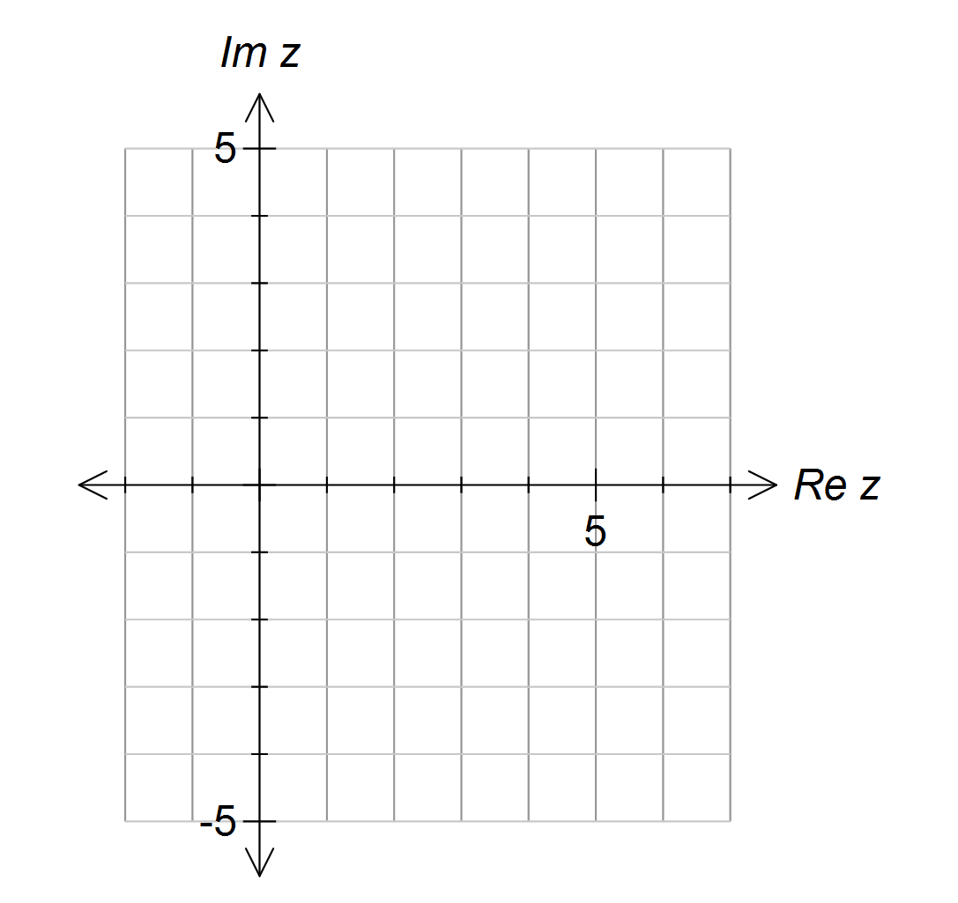

3. [9 marks: 2, 2, 5]  
  
Find the following indefinite integrals:  
  
(a) 

(b) 

(c) 

4. [3 marks]  
  
A cubic function, *q*(*x*), intersects the *x*-axis at (*a*, 0), (*b*, 0) and (*c*, 0) .   
Another function, *p*(*x*), intersects *q*(*x*) in three places.   
The coordinates of two of these points are shown on the graph below.



Use the information in the graph to define the shaded area in terms of definite integrals.

5. [7 marks: 3, 4]  
  
The line L has equation ***r*** = 4 **i** + 3 **j** − **k** + λ(**i** + 2 **j** − 2 **k**).  
The plane  has equation ***r*** • (−**i** + **j** + **k** ) = 2.  
  
(a) Find the position vector of the point of intersection between L and .  
  
  
  
  
  
  
  
  
  
  
  
  
  
  
  
  
  
  
(b) The acute angle between L and  is θ. Find sin θ.

6. [6 marks: 3, 3]  
Consider a 2 × 2 matrix, **A** =    
(a) If **A**2 = α**A** + β**I** where α and β are real numbers and **I** is the 2 × 2 unit matrix,

find α and β.

(b) Write **A**4 in the form *k***A** + *c***I** where *k* and *c* are real numbers and   
 **I** is the 2 × 2 unit matrix.

7. [6 marks: 2, 2, 2]  
  
Let *u* = *a* *cis* α and *w* = *b*  where *a* and *b* are real numbers and −π < α ≤ π and   
−π < β ≤ π.  
(a) State the modulus and argument of .  
  
  
  
  
(b) Given that *u* and *w* are the two roots of the equation *z*2 = *k*, find:  
 (i) the relationship between *a* and *b*

(ii) the relationship between α and β.  
  
  
  
  
  
(c) Given that *u* and *w* are the two roots of the equation *pz*2 + *qz* + *r* = 0,   
 where *p*, *q* and *r* are non-zero real numbers, find:  
 (i) the relationship between *a* and *b*

(ii) the relationship between α and β.

BLANK PAGE

BLANK PAGE

BLANK PAGE